START THE YEAR RIGHT PROGRESS REPORT
STYR-LOC
The campaign started with 11.79 million records in the pool. By the time anything reached a client, the number was down to 48,748, less than half a percent of where it began.
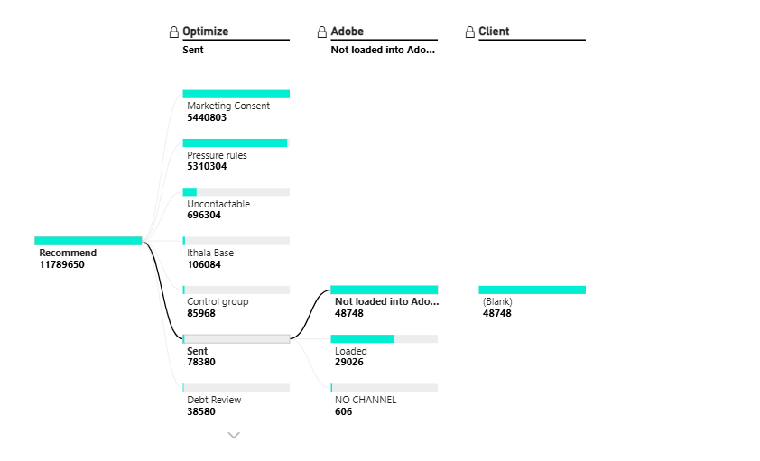
The biggest drop happens at Optimize. Over 11.7 million records never made it past this stage, mostly due to Marketing Consent (5.44M) and Pressure Rules (5.3M). These two alone accounts for the bulk of the audience before the campaign even gets going. Everything else like Uncontactable, Control Group, Debt Review and the rest is relatively minor by comparison.
Recommend | Optimize | Adobe | Client
5440803 | Marketing Consent
5299144 | Pressure rules
696304 | Uncontactable
106084 | Ithala Base
85968 | Control group
48748 | Sent | Not loaded into Adobe within 5 days
38580 | Debt Review
29026 | Sent | Loaded | Sent
14538 | Strategic prioritisation
13018 | VIP
10856 | Pressure rules | Loaded | Sent
4334 | Strategic prioritisation | Loaded | Sent
720 | Deceased
606 | Sent | NO CHANNEL | NO CHANNEL
304 | Pressure rules | NO CHANNEL | NO CHANNEL
258 | AdobeExport:Duplicate Recipient
127 | Undesirables_M
111 | Strategic prioritisation | NO CHANNEL | NO CHANNEL
71 | Non-staged
25 | Redlist
19 | Brand check
2 | Invalid ID
2 | Undesirables_E
1 | AdobeExport:excluded Segments
1 | Incorrect Sub Segment

The 44,216 that made it into Adobe all reached the client with no further loss, with the total made up of the 29,026 that passed Optimize cleanly plus an additional 15,190 that came through despite being flagged under Pressure Rules and Strategic Prioritisation at the Optimize stage.
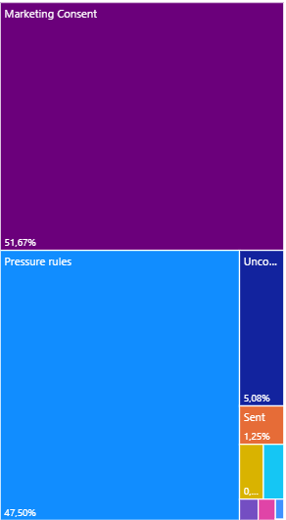
The 13 March drop was the largest, roughly 5.5M recommended with most lost at Optimize and around 16,600 making it through to Adobe. The 24 March, 13 April and 14 April drops show a consistent issue where records passed Optimize but nothing loaded into Adobe, with every record either timing out or hitting no channel. The 23 and 24 April drops performed better with records successfully loading through. The small March drops on the 10th and 12th were clean with most records delivered successfully.
In summary, Marketing Consent and Pressure Rules are filtering out almost the entire audience at the start, and Adobe loading failures are responsible for the majority of what is lost after that.
STYR-MOTOR
The campaign started with 959,098 records. Of those, 41,539 (4.3%) passed Optimize and were marked as Sent, which is a notably better pass rate than the LOC campaign.
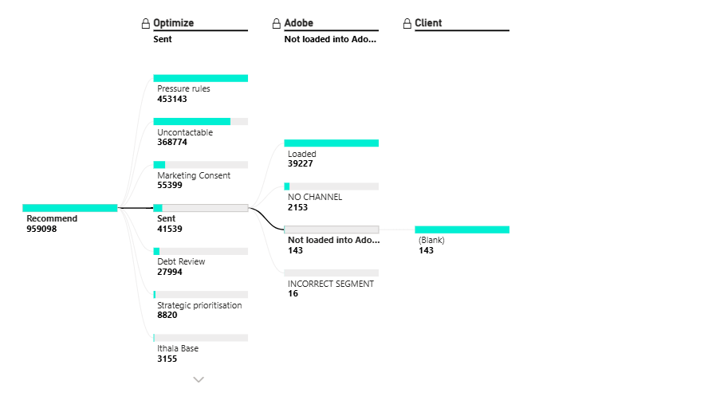

The main Optimize blockers are Pressure Rules at 453K and Uncontactable at 369K, which together account for 86% of everything filtered out. Marketing Consent at 55K and Debt Review at 28K follow at a much smaller scale.
Recommend | Optimize | Adobe | Client
453096 | Pressure rules
368774 | Uncontactable
55399 | Marketing Consent
39227 | Sent | Loaded | Sent
27993 | Debt Review
8820 | Strategic prioritisation
3155 | Ithala Base
2153 | Sent | NO CHANNEL | NO CHANNEL
143 | Sent | Not loaded into Adobe within 5 days
115 | AdobeExport:Duplicate Recipient
93 | Deceased
47 | Pressure rules | NO CHANNEL | NO CHANNEL
24 | Undesirables_M
16 | Sent | INCORRECT SEGMENT | INCORRECT SEGMENT
13 | VIP
12 | Control group
7 | Redlist
4 | Non-staged
3 | Brand check
2 | AdobeExport:excluded Segments
1 | Debt Review | NO CHANNEL | NO CHANNEL
1 | Incorrect Sub Segment

The 41,539 that passed Optimize ran into a second problem at Adobe. 143 records timed out on the 5 day loading window, 2,201 had no channel available, and 16 were flagged as Incorrect Segment. That is roughly 5% of the passed pool lost at this stage.
The 39,227 that made it into Adobe all reached the client with no further loss.
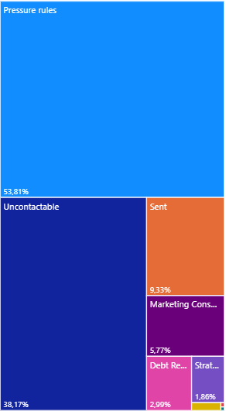
Looking across the drop dates, all three April dates carried similar recommended volumes of around 313K to 317K each. The 21 April drop passed the most through Optimize at 31,717, while 14 April only passed 2,192 despite a similar volume coming in. The 24 April drop passed 7,627. Timeouts and no channel failures are present but minor across all dates after Optimize.
In summary, Pressure Rules and Uncontactable are filtering out the bulk of the audience upfront. Unlike the LOC campaign, what passed Optimize largely made it through to the client with minimal loss at the Adobe stage.

